Designing Logical Solutions for Sierra Leone Community Challenges
Rural School Attendance and Results Tracker (RSART)
PROG101: Principles of Programming Logic and Design | Individual Assignment 1
Limkokwing University of Creative Technology, Sierra Leone | Department of Information and Communication Technology | Semester 01, September 2026 to January 2027
Student Name: [Your Full Name]
Student ID: [Your Student ID]
Examiner: Elijah Fullah
Submission: Week 4
GitHub Repository: https://github.com/[your-username]/PROG101_Assignment1_[StudentName]_[StudentID]

Table of Contents
- Rationale (Problem Description, Background, Community Impact, Proposed Solution, Computational Thinking, Algorithm Design, SDG Alignment, Open Source Justification, Digital Public Goods Justification)
- Algorithm
- Pseudocode
- Flowcharts
- Functional Modules
- Expected Outputs
- GitHub Evidence
- References

1. Rationale

1.1 Problem Description
Picture a teacher in a village school with sixty pupils and one paper register. Every morning the names are ticked by hand. At the end of term the scores are added up with a pencil and the grades worked out one by one, and a single rainy season can destroy the only copy of the records. Many rural schools in Sierra Leone will recognise this, especially where electricity and internet are unreliable. Mistakes creep in, and nobody higher up sees the numbers in time, so a child who keeps missing class or keeps failing is often noticed too late.
The problem to be solved is therefore: how can a rural school record attendance and results accurately, calculate grades automatically, and identify at-risk students early, even where electricity and internet access are unreliable?
Who is affected: students and their parents or guardians, teachers, head teachers, and district education officers.
Why the problem exists: limited funding for equipment, unreliable electricity and internet, shortage of trained staff, large class sizes, and the absence of a simple, low-cost, locally suitable record-keeping system.

1.2 Background
Sierra Leone has worked hard to get more children into school, and the Free Quality School Education programme introduced in 2018 is part of that effort. More pupils in class is good news, but it also means more registers to fill and more marks to add up, usually by the same few teachers. Knowing who is attending and who is falling behind helps a head teacher plan and helps the district decide where to send support. Before anyone writes software for this, the logic has to be right, which is why this assignment is about design and not code.

1.3 Community Impact
- Problem being solved: slow, error-prone and easily lost paper records of attendance and results.
- Expected impact: teachers save time on calculations; grades are consistent and correct; at-risk students are flagged early so that teachers and parents can intervene; head teachers and district officers get clear class reports.
- Beneficiaries: rural students, parents and guardians, teachers, head teachers, and district education offices.
- Long-term sustainability: the design is offline-first, needs only basic hardware (a low-cost phone, tablet or shared laptop), uses open-source tools with no licence fees, and can be maintained by local ICT graduates and school communities.

1.4 Proposed Solution
RSART is a simple system a teacher can use every day. They log in, register their pupils, tick attendance and enter scores after each test. The system then works out the attendance percentage, average and grade on its own, and warns the teacher when a pupil is at risk because of low attendance or low marks. At the end it produces a class report. Everything is saved on the device first, so it keeps working when the internet is down, and it sends the data to the district office when a connection comes back.

1.5 Computational Thinking Process
Technique | Application to the problem
Decomposition | The large problem is broken into smaller tasks: login, student registration, attendance marking, score entry, grade calculation, risk detection, reporting, and data synchronisation. Each becomes a module.
Pattern recognition | Every student goes through the same steps (attendance, scores, average, grade, risk check), so a repetition structure can process the whole class. Every subject uses the same score validation rule.
Abstraction | Details such as school colour, textbook titles or teacher timetables are ignored. Only the data needed is kept: student ID, name, class, days present, total days, and scores.
Algorithm design | The ordered steps, decisions and loops are written as an algorithm, then as pseudocode and flowcharts (Sections 2 to 4).

1.6 Algorithm Design (Summary)
The system follows the Input, Processing, Output model.
- Input: login details, student details, daily attendance (P or A), subject scores (0 to 100).
- Processing: validate inputs; update days present; calculate attendance percentage; calculate average score; assign grade; test the at-risk condition; count totals for the class.
- Output: confirmation messages, individual student summary, at-risk alerts, and class report.
The main program is a menu inside a loop. Each menu option calls its own function, which keeps the design modular and easy to test. IF and CASE statements handle the checks, such as validating input, choosing a grade and spotting at-risk pupils.

1.7 SDG Alignment
- SDG 4: Quality Education (primary). The system supports inclusive and equitable quality education by keeping students in school and learning, and by identifying learners who need support.
- SDG 10: Reduced Inequalities (supporting). Rural children receive the same quality of record-keeping and early support as urban children.
- SDG 9: Industry, Innovation and Infrastructure (supporting). The design builds local digital capacity using low-cost, offline-capable technology.

1.8 Open Source Justification
Why RSART should be open source: schools and districts cannot afford licence fees, and a closed system would lock them to one vendor. Open source lets anyone inspect the logic, check that student data is handled fairly, and adapt grading rules to different school levels.
Benefits for Sierra Leone:
- No licence costs, so more of the education budget reaches classrooms.
- Local developers and students can learn from, fix and improve the system, building national ICT skills.
- The system can be translated or adapted (for example to Krio-friendly wording or different grade boundaries) without waiting for a foreign company.
- Transparency builds trust among teachers, parents and the Ministry.
Potential community contributions: university students can add new features and test the design; teachers can suggest improvements to the workflow; translators can localise the interface; other schools can share grade boundaries and report templates; security-minded contributors can review data protection.

1.9 Digital Public Goods Justification
A Digital Public Good (DPG) is open-source software, data or content that protects privacy, does no harm and helps reach the SDGs. RSART could become one by:
- Releasing the design and any future code under an open licence (for example MIT or Apache 2.0) with clear documentation on GitHub.
- Protecting student privacy (collecting only necessary data, restricting access by login, and supporting anonymised reports).
- Using open data formats such as CSV or JSON so that it can connect with other education systems.
- Directly supporting SDG 4.
It promotes accessibility (works offline and on low-cost devices), openness (anyone can view, reuse and improve it) and public benefit (free for every school, with data helping the whole education system).

2. Algorithm
Main algorithm (step by step):
- Start the program and load saved data from the device.
- Ask the user for username and PIN. Allow a maximum of 3 attempts. If all fail, display an access-denied message and stop.
- Display the main menu: (1) Register student, (2) Mark attendance, (3) Enter scores, (4) View student summary, (5) Class report, (6) Synchronise data, (7) Exit.
- Read the user's choice.
- Use a decision structure to run the module that matches the choice. If the choice is invalid, display an error message.
- Return to step 3 until the user chooses Exit.
- Save all data and stop.
Algorithm for Mark Attendance:
- Ask for the class and date.
- For each student in the class: ask for status (P for present, A for absent) until a valid value is entered.
- Add 1 to the student's total days. If the status is P, also add 1 to days present.
- Save the record and display a confirmation.
Algorithm for Enter Scores:
- Ask for the class and subject.
- For each student: ask for the score until it is between 0 and 100.
- Store the score in the student's score list.
Algorithm for Student Summary:
- Ask for the student ID and find the student.
- Calculate attendance percentage = (days present / total days) x 100.
- Calculate average score = sum of scores / number of scores.
- Assign a grade from the average.
- If attendance is below 75 percent OR average is below 50, mark the student as at risk.
- Display the summary.

3. Pseudocode
CONSTANT PASS_MARK = 50 // Integer
CONSTANT MAX_SCORE = 100 // Integer
CONSTANT MIN_ATTENDANCE = 75 // Integer (percent)
CONSTANT MAX_LOGIN_ATTEMPTS = 3 // Integer
RECORD Student
studentID : String
fullName : String
classLevel : String
daysPresent : Integer
totalDays : Integer
scores : List of Real
END RECORD
DECLARE students AS List of Student
PROGRAM RuralSchoolTracker
CALL loadData()
IF loginUser() = FALSE THEN
DISPLAY 'Access denied. Program closed.'
STOP
END IF
SET running = TRUE // Boolean
WHILE running = TRUE DO
CALL showMenu()
INPUT choice // Integer
CASE choice OF
1 : CALL registerStudent()
2 : CALL markAttendance()
3 : CALL enterScores()
4 : CALL showStudentSummary()
5 : CALL generateClassReport()
6 : CALL syncData()
7 : SET running = FALSE
OTHERWISE : DISPLAY 'Invalid choice. Try again.'
END CASE
END WHILE
CALL saveData()
DISPLAY 'Goodbye.'
END PROGRAM
FUNCTION loginUser() RETURNS Boolean
SET attempts = 0
WHILE attempts < MAX_LOGIN_ATTEMPTS DO
INPUT username, pin
IF verifyCredentials(username, pin) = TRUE THEN
RETURN TRUE
ELSE
SET attempts = attempts + 1
DISPLAY 'Wrong username or PIN.'
END IF
END WHILE
RETURN FALSE
END FUNCTION
MODULE registerStudent()
INPUT id, name, classLevel
IF studentExists(id) = TRUE THEN
DISPLAY 'Student ID already registered.'
ELSE
CREATE newStudent WITH id, name, classLevel, 0, 0, EMPTY LIST
ADD newStudent TO students
DISPLAY 'Student registered successfully.'
END IF
END MODULE
MODULE markAttendance()
INPUT classLevel, dateToday
FOR EACH s IN students DO
IF s.classLevel = classLevel THEN
REPEAT
DISPLAY 'Status for ', s.fullName, ' (P/A): '
INPUT status // String
UNTIL status = 'P' OR status = 'A'
SET s.totalDays = s.totalDays + 1
IF status = 'P' THEN
SET s.daysPresent = s.daysPresent + 1
END IF
END IF
END FOR
DISPLAY 'Attendance saved for ', dateToday
END MODULE
MODULE enterScores()
INPUT classLevel, subject
FOR EACH s IN students DO
IF s.classLevel = classLevel THEN
REPEAT
DISPLAY 'Score for ', s.fullName, ' in ', subject, ': '
INPUT score // Real
UNTIL score >= 0 AND score <= MAX_SCORE
ADD score TO s.scores
END IF
END FOR
DISPLAY 'Scores saved.'
END MODULE
FUNCTION calculateAttendancePercentage(present, total) RETURNS Real
IF total = 0 THEN
RETURN 0
END IF
RETURN (present / total) * 100
END FUNCTION
FUNCTION calculateAverage(scoreList) RETURNS Real
IF LENGTH(scoreList) = 0 THEN
RETURN 0
END IF
SET sum = 0
FOR EACH value IN scoreList DO
SET sum = sum + value
END FOR
RETURN sum / LENGTH(scoreList)
END FUNCTION
FUNCTION calculateGrade(average) RETURNS String
IF average >= 80 THEN
RETURN 'A'
ELSE IF average >= 70 THEN
RETURN 'B'
ELSE IF average >= 60 THEN
RETURN 'C'
ELSE IF average >= PASS_MARK THEN
RETURN 'D'
ELSE
RETURN 'F'
END IF
END FUNCTION
FUNCTION isAtRisk(attendancePct, average) RETURNS Boolean
RETURN (attendancePct < MIN_ATTENDANCE) OR (average < PASS_MARK)
END FUNCTION
MODULE showStudentSummary()
INPUT id
SET s = findStudent(id)
IF s = NOT FOUND THEN
DISPLAY 'No student with that ID.'
ELSE
SET pct = calculateAttendancePercentage(s.daysPresent, s.totalDays)
SET avg = calculateAverage(s.scores)
SET grade = calculateGrade(avg)
DISPLAY s.fullName, pct, avg, grade
IF isAtRisk(pct, avg) = TRUE THEN
DISPLAY 'ALERT: Student is AT RISK. Contact parent/guardian.'
END IF
END IF
END MODULE
MODULE generateClassReport()
INPUT classLevel
SET count = 0, atRiskCount = 0, classTotal = 0, topAverage = 0
SET topStudent = ''
FOR EACH s IN students DO
IF s.classLevel = classLevel THEN
SET pct = calculateAttendancePercentage(s.daysPresent, s.totalDays)
SET avg = calculateAverage(s.scores)
SET count = count + 1
SET classTotal = classTotal + avg
IF avg > topAverage THEN
SET topAverage = avg
SET topStudent = s.fullName
END IF
IF isAtRisk(pct, avg) = TRUE THEN
SET atRiskCount = atRiskCount + 1
END IF
DISPLAY s.fullName, pct, avg, calculateGrade(avg)
END IF
END FOR
IF count > 0 THEN
DISPLAY 'Class average: ', classTotal / count
DISPLAY 'Top student: ', topStudent
DISPLAY 'Students at risk: ', atRiskCount
ELSE
DISPLAY 'No students found in this class.'
END IF
END MODULE
MODULE syncData()
IF isConnected() = TRUE THEN
FOR EACH record IN unsyncedRecords DO
UPLOAD record TO districtServer
END FOR
DISPLAY 'Data synchronised.'
ELSE
DISPLAY 'No connection. Data saved on device and will sync later.'
END IF
END MODULE

4. Flowcharts
Three flowcharts cover the main program, attendance marking, and the at-risk check. Each one follows the standard symbols: oval for start and end, parallelogram for input and output, rectangle for process, and diamond for decision.
Flowchart 1: Main program. After a valid login the program shows the menu and runs the chosen module until the user selects Exit.
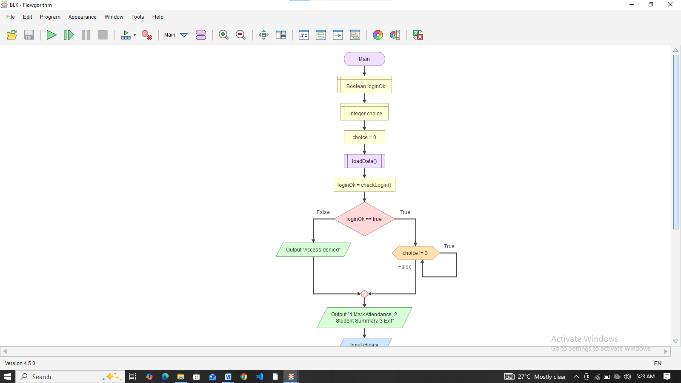
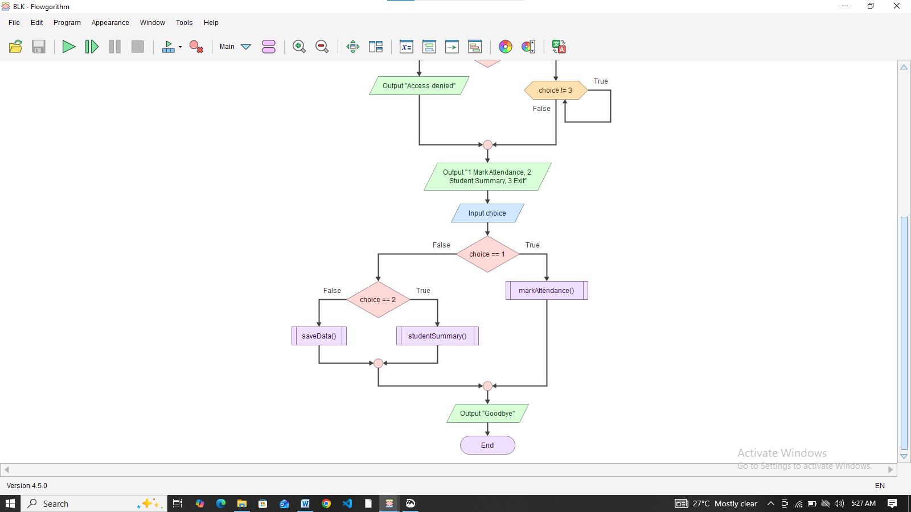
Flowchart 2: Mark Attendance module. Each student is processed in a loop. The status is re-requested until it is P or A, and days present rises only for P.
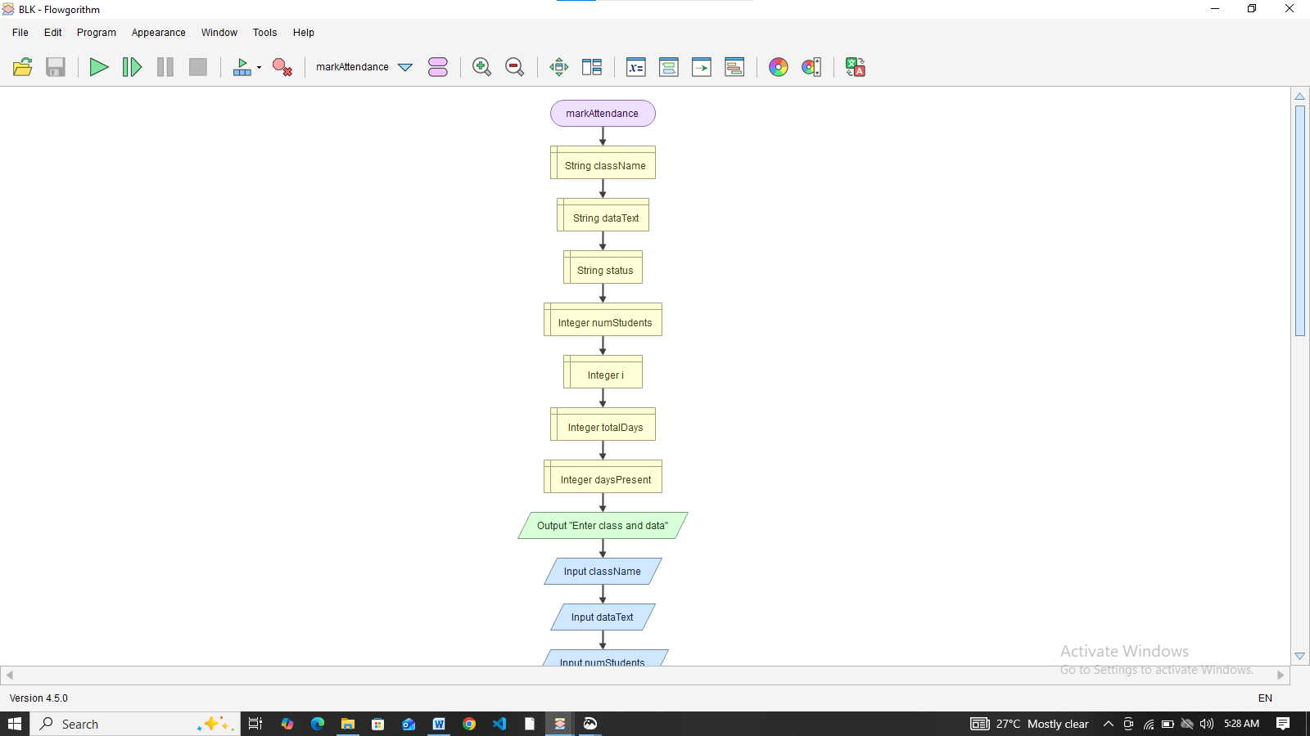
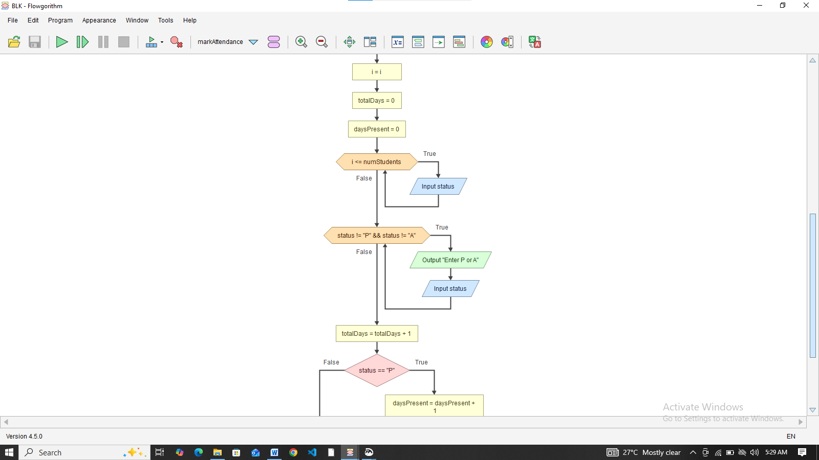
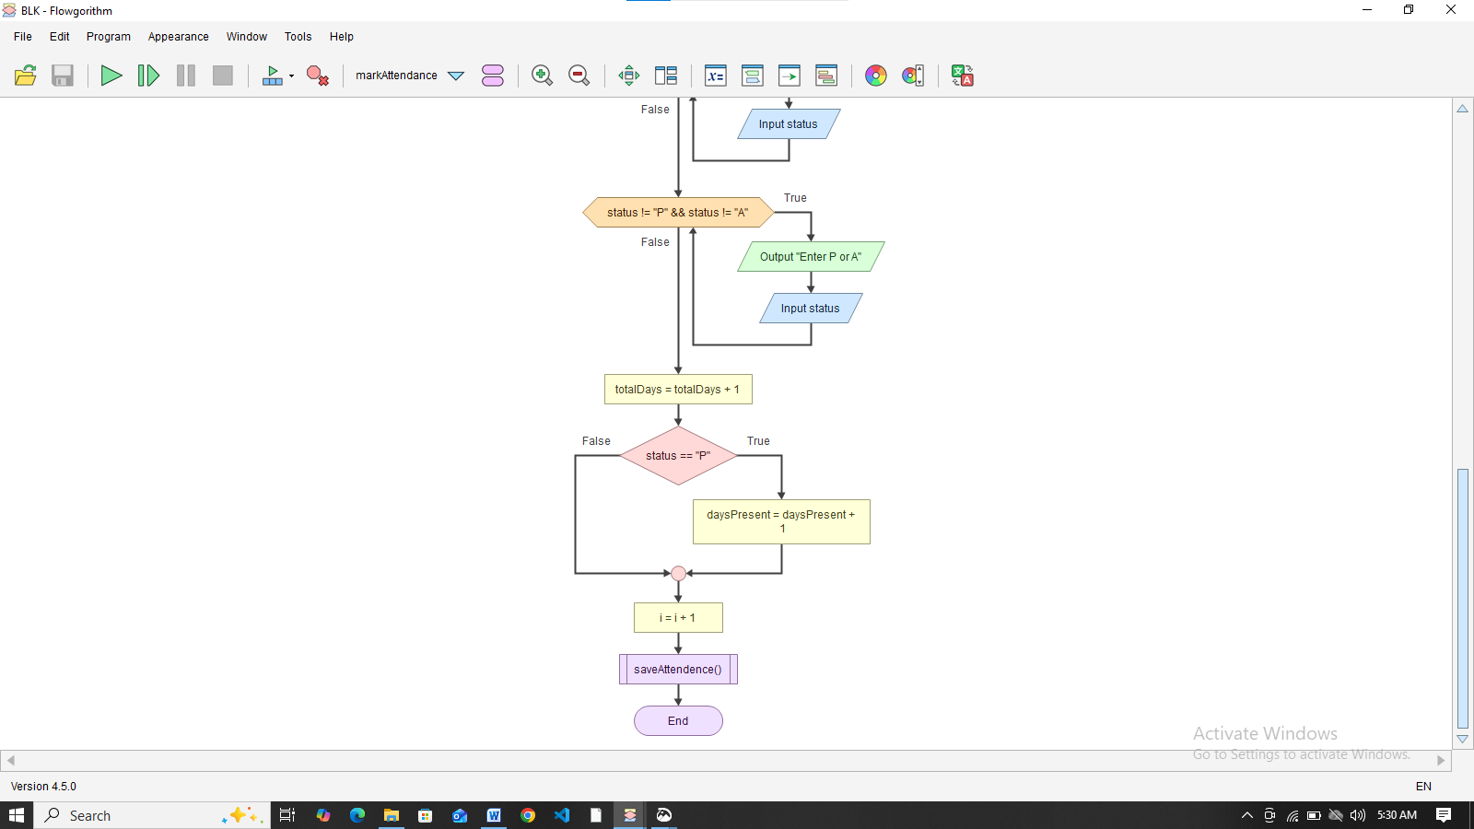
Flowchart 3: Student Summary and risk check. Attendance percentage, average and grade are calculated, then the OR rule decides whether the at-risk alert is shown.
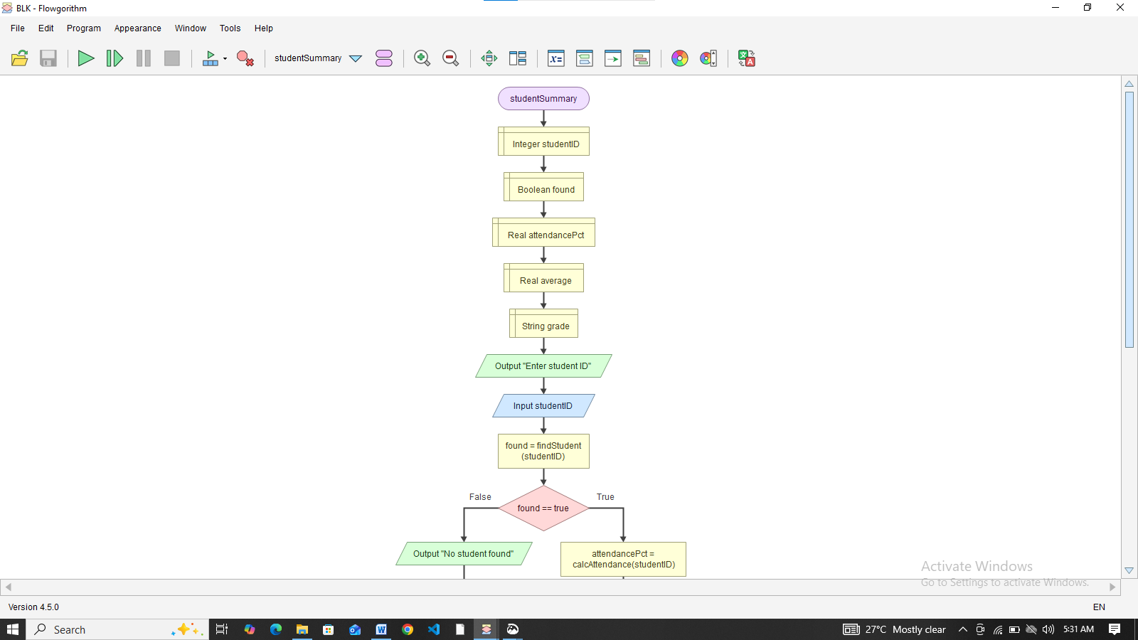
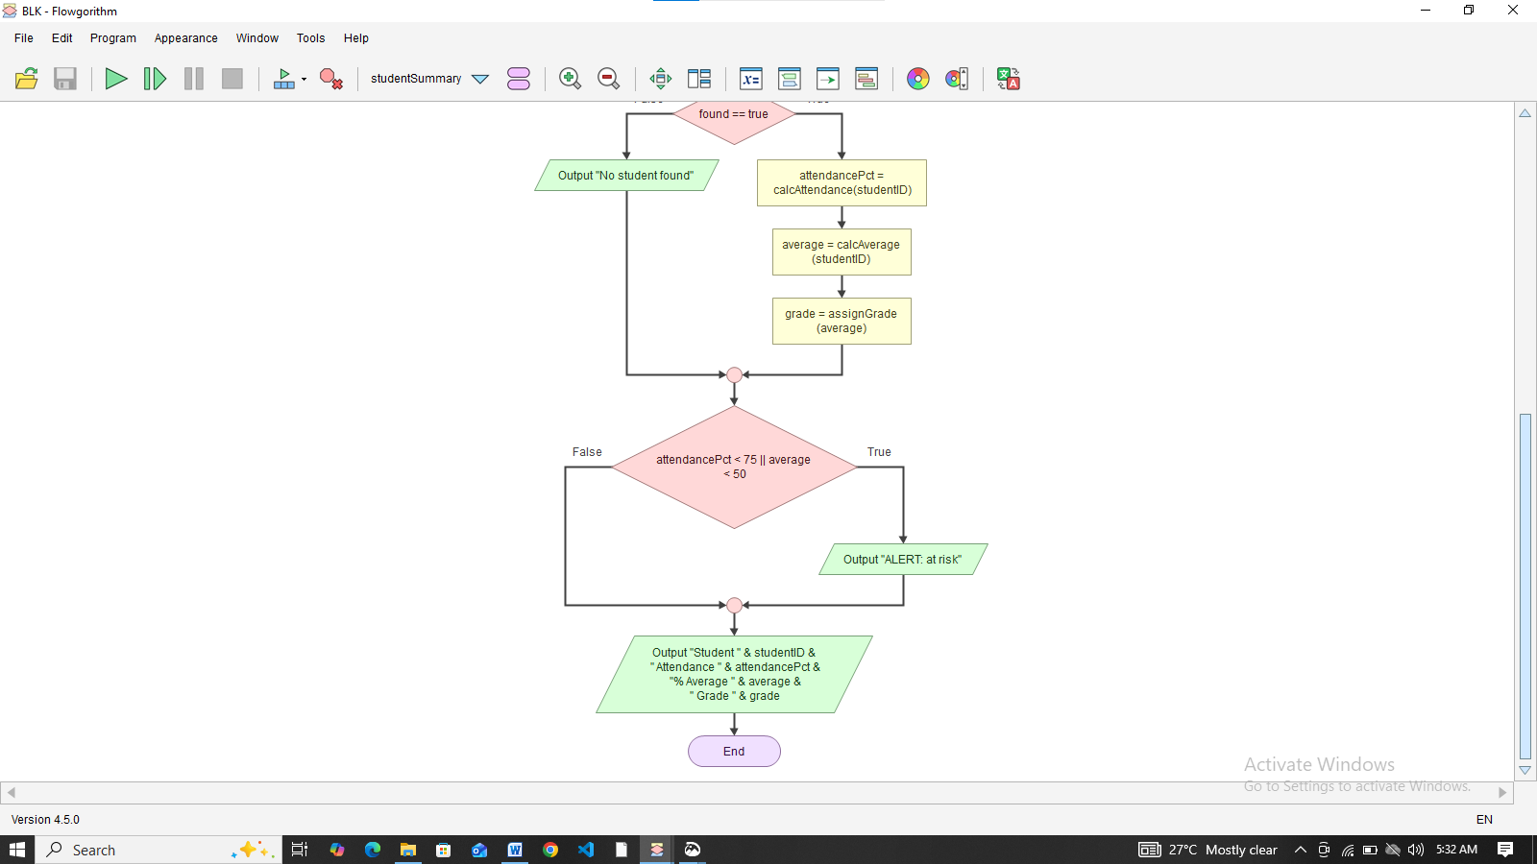

5. Functional Modules
Module / Function | Purpose | Input | Output | Logic used
main program | Controls the whole system | Menu choice | Calls other modules | Repetition (WHILE), CASE decision
loginUser() | Verifies the teacher | Username, PIN | TRUE or FALSE | Repetition, decision, Boolean
registerStudent() | Adds a new student | ID, name, class | Confirmation or error | Decision (duplicate check)
markAttendance() | Records daily attendance | Class, date, P or A | Updated days | FOR EACH loop, REPEAT-UNTIL validation
enterScores() | Records subject scores | Class, subject, score | Updated score list | Loop, range validation with AND
calculateAttendancePercentage() | Computes attendance percent | Days present, total days | Real number | Decision (divide-by-zero guard)
calculateAverage() | Computes average score | Score list | Real number | Loop and accumulator
calculateGrade() | Converts average to grade | Average | A, B, C, D or F | IF / ELSE IF chain
isAtRisk() | Detects at-risk students | Attendance percent, average | TRUE or FALSE | Boolean logic (OR)
showStudentSummary() | Displays one student's results | Student ID | Summary and alert | Decision, function calls
generateClassReport() | Summarises a class | Class level | Table, average, top student, at-risk count | Loop, counters, comparison
syncData() | Uploads records when online | Unsynced records | Status message | Decision, loop
Variables, constants and data types
Item | Type | Example
studentID, fullName, classLevel, status | String | 'SL-001', 'Aminata Kamara', 'JSS1', 'P'
daysPresent, totalDays, choice, attempts | Integer | 18, 20, 2, 1
score, average, attendancePct | Real | 72.0, 65.0, 90.0
running, isAtRisk result | Boolean | TRUE, FALSE
scores | List of Real | [72, 65, 58]
PASS_MARK, MIN_ATTENDANCE, MAX_SCORE | Constants (Integer) | 50, 75, 100

6. Expected Outputs
The following sample scenarios use a class of JSS1 with 20 school days recorded and three subjects (Mathematics, English, Integrated Science). Grade boundaries: A is 80 and above, B is 70 to 79, C is 60 to 69, D is 50 to 59, F is below 50. At-risk rule: attendance below 75 percent OR average below 50.
Scenario 1: Good student (Aminata Kamara, SL-001)
- Days present: 18 of 20, attendance = 90 percent.
- Scores: 72, 65, 58. Average = 65.0, Grade = C.
- At risk? Attendance is not below 75 and average is not below 50, so FALSE.
- Output: Aminata Kamara | Attendance: 90% | Average: 65.0 | Grade: C | Status: OK
Scenario 2: Student failing both rules (Mohamed Sesay, SL-002)
- Days present: 12 of 20, attendance = 60 percent.
- Scores: 48, 40, 47. Average = 45.0, Grade = F.
- At risk? TRUE because both conditions are met.
- Output: Mohamed Sesay | Attendance: 60% | Average: 45.0 | Grade: F | ALERT: AT RISK. Contact parent/guardian.
Scenario 3: Good marks but poor attendance (Fatmata Conteh, SL-003)
- Days present: 14 of 20, attendance = 70 percent.
- Scores: 70, 60, 56. Average = 62.0, Grade = C.
- At risk? TRUE because attendance is below 75 (the OR condition is satisfied by one part).
- Output: Fatmata Conteh | Attendance: 70% | Average: 62.0 | Grade: C | ALERT: AT RISK.
Scenario 4: Invalid input handling
- A teacher enters a score of 120 for Mathematics. The system displays an error and asks again until a value between 0 and 100 is entered.
- A teacher enters X for attendance. The system repeats the question until P or A is entered.
- Three wrong PIN attempts: Access denied. Program closed.
Scenario 5: Class report (JSS1)
Name Attendance Average Grade Status
Aminata Kamara 90% 65.0 C OK
Mohamed Sesay 60% 45.0 F AT RISK
Fatmata Conteh 70% 62.0 C AT RISK
-------------------------------------------------------
Class average: 57.3
Top student: Aminata Kamara
Students at risk: 2
Scenario 6: Offline synchronisation
- No connection: No connection. Data saved on device and will sync later.
- Connection available: Data synchronised.

7. GitHub Evidence
Repository name (required format): PROG101_Assignment1_StudentName_StudentID
Repository URL: [paste your repository link here]
Files to upload: the report (PDF), flowcharts (PNG or .mmd files), pseudocode (.txt or .md), and README.md.
Suggested commit history (make real commits as you work, a few per day, so the history shows steady progress):
- Initial commit: add README.md
- Add problem analysis and rationale draft
- Add step-by-step algorithm
- Add pseudocode for main program and login
- Add pseudocode for attendance and score modules
- Add flowchart for main program
- Add flowchart for attendance and grading
- Add sample outputs and module table
- Add SDG, open source and DPG sections
- Final report formatting and submission

README.md outline:
- Project title: Rural School Attendance and Results Tracker (RSART)
- Problem statement (two or three sentences)
- Proposed solution and main modules
- SDG supported: SDG 4 Quality Education
- Folder structure (report, flowcharts, pseudocode)
- How to read the design documents
- Open licence statement (for example MIT)
- Author: your name and student ID, PROG101, Limkokwing University of Creative Technology, Sierra Leone
Screenshots to attach: repository home page, commit history page, and README.md rendered vi

Conclusion
RSART is a modular, offline-first design that helps rural Sierra Leonean schools record attendance and results, calculate grades automatically, and flag at-risk pupils early. Using computational thinking, the problem was broken into modules and expressed as an algorithm, pseudocode and flowcharts, with sequence, selection and repetition throughout. The sample scenarios confirm that grading, the at-risk rule ( attendance below 75% or average below 50), input validation and class reporting all work correctly. Released as open source, RSART would support SDG 4 and could become a Digital Public Good, and the next step is turning this design into working code.

References
- United Nations. Sustainable Development Goals, Goal 4: Quality Education. https://sdgs.un.org/goals/goal4
- Digital Public Goods Alliance. The Digital Public Goods Standard. https://digitalpublicgoods.net
- Open Source Initiative. The Open Source Definition. https://opensource.org/osd
- Government of Sierra Leone, Ministry of Basic and Senior Secondary Education. Free Quality School Education programme documents.
- GitHub Docs. About repositories and commits. https://docs.github.com
- Limkokwing University of Creative Technology, Sierra Leone. PROG101 Assignment brief, September 2026.

